Pillar 5: Capstone Project
Step 1:
- Problem Clearly Framed with Strong Business Context and Data Science Perspective.
- Business Context
Student dropout is a major challenge for higher education institutions because it reduces graduation rates, affects university reputation, and results in financial losses from reduced tuition revenue. Most universities identify at-risk students only after their academic performance has significantly declined, limiting the effectiveness of intervention programs. To address this problem, this project develops an AI-based Early Warning System that predicts students who are at risk of dropping out. The prediction enables universities to provide timely interventions such as academic advising, financial assistance, and mentoring before students decide to leave their studies.
- Data Science Perspective
This project uses historical student demographic, academic, financial, and socioeconomic data to build a machine learning model that predicts dropout risk. The workflow includes data preprocessing, feature engineering, model training, model evaluation, and explainability to support data-driven decision-making in higher education.
- Task Type and Justification
Supervised Learning - Binary Classification
The objective is to predict whether a student is at risk of dropping out based on historical student information. Although the original educational datasets often contain multiple outcomes, the prediction problem is reformulated into two classes:
Target | Meaning
1 | Dropout
0 | Continue (Graduate or Enrolled)
This binary formulation aligns with the university's operational objective of identifying students who require intervention before permanently leaving their studies. Binary classification also provides clearer decision boundaries, simplifies model interpretation, and enables direct implementation within an Early Warning System.
- Success Metrics and Business KPIs.
- Technical Success Metrics
Metric | Purpose
Accuracy | Measures overall prediction performance.
Precision | Evaluates how many predicted at-risk students are actually at risk.
Recall | Measures the model's ability to correctly identify students who will drop out. This is the primary metric because missing an at-risk student has a higher cost than issuing a false alarm.
F1-Score | Balances Precision and Recall.
- Business KPIs
The proposed AI solution aims to support the following business outcomes:
- Improve student retention rate through early intervention.
- Reduce student dropout rate.
- Increase graduation rate.
- Help academic advisors prioritize high-risk students more effectively.
- Improve the efficiency of student support programs by focusing resources on students who need them most.

Step 2: Data Collection & Understanding
- Dataset Selection and Justification.
The dataset is taken from UCI Machine Learning Repository with the title ”Predict Student’s Dropout and Academic Success” based from the data of a high education institute in Portugal. (https://archive.ics.uci.edu/dataset/697/predict+students+dropout+and+academic+success)
The dataset comes with 36 features and a target that consists of three classes: Dropout, Enrolled, Graduate. The dataset is made of a mix of categorical and numerical features.
These characteristics make the dataset suitable for developing an AI-based Early Warning System for identifying students at risk of dropping out.
- Dataset Overview.
Feature Category | Examples
Demographic Information | Gender, Age at enrolment, Nationality, Marital status
Academic Background | Previous qualification, Admission grade, Previous qualification grade
Enrollment Information | Course, Application mode, Attendance type
Financial Information | Tuition fees status, Debtor status, Scholarship holder
Academic Performance | Semester 1 and Semester 2 enrolled units, approved units, grades
Socioeconomic Information | Parents' qualification, parents' occupation, unemployment rate, GDP
A missing value analysis was performed to identify incomplete records.
Result:
- There are 4424 entries of historical data with no missing values.
- Therefore, no imputation technique was required.
Duplicate records were checked to ensure data quality.
Result:
- No duplicate student records were identified.
Outlier detection was performed using the Interquartile Range (IQR) method for numerical variables.
Variables analyzed include:
- Age at enrollment
- Admission grade
- Semester grades
- Number of enrolled/approved credits
- Economic indicators
Some numerical variables contain potential outliers due to natural variations in student characteristics and academic performance. These observations were not removed because they represent meaningful student cases rather than data errors.
The target distribution was analyzed to understand class balance before model development. Because dropout prediction focuses on identifying at-risk students, the target variable was transformed into a binary classification problem:
Student Outcome | Transformed Class | Description
Graduate | 0 | Student successfully completed studies
Dropout | 1 (At Risk) | Student discontinued studies
Enrolled | 0 | Student is still studying

- Data Dictionary
Variable | Type | Description | Range / Values
Age at enrollment | Numerical | Student age when enrolling | Years
Gender | Categorical | Student gender | 0 = Female, 1 = Male
Scholarship holder | Categorical | Scholarship status | 0 = No, 1 = Yes
Debtor | Categorical | Student has financial debt | 0 = No, 1 = Yes
Tuition fees up to date | Categorical | Tuition payment status | 0 = No, 1 = Yes
Admission grade | Numerical | Student admission score | 0–200
Curricular units 1st sem (grade) | Numerical | Average grade in semester 1 | 0–20
Curricular units 2nd sem (grade) | Numerical | Average grade in semester 2 | 0–20
Target | Categorical | Student final outcome | Graduate, Dropout, Enrolled
The complete data dictionary is provided separately as part of the project documentation.
Step 3: Data Preprocessing, Applied EDA & Feature Engineering
- Data Preprocessing
The dataset was cleaned and prepared before model development. The preprocessing steps included checking for duplicate records, encoding categorical variables, one-hot encoding multi-class features, scaling numerical variables, and splitting the dataset into training and testing sets.
- Check Duplicate Records
data.drop_duplicates()
- Encode Target Variable
from sklearn.preprocessing import LabelEncoder

le = LabelEncoder()
data_final["Target"] = le.fit_transform(data_final["Target"])
- One-Hot Encoding
data_one_hot = pd.get_dummies(
data_final,
columns=to_one_hot,
drop_first=True,
dtype=int
)
- Feature Scaling
from sklearn.preprocessing import StandardScaler

scaler = StandardScaler()
X_train_scaled = pd.DataFrame(
scaler.fit_transform(X_train),
columns=X_train.columns
)
X_test_scaled = pd.DataFrame(
scaler.transform(X_test),
columns=X_test.columns
)
No missing values were found in the dataset, and duplicate records were checked before analysis.
- Feature Engineering
Feature engineering was performed to improve model usability and interpretability. The following transformations were applied:
- Label Encoding for the target variable.
- One-Hot Encoding for categorical variables with multiple categories.
- Binary variables were preserved as numeric (0/1).
- Human-readable mappings were created for education level, occupation, application mode, course, and nationality to improve data interpretation.
Example:
for col in binary_features:
if data_final[col].dtype == "object":
data_final[col] = (
data_final[col]
.astype("category")
.cat.codes
)
These transformations ensure that all input features are suitable for machine learning algorithms while preserving their semantic meaning.
- Applied Exploratory Data Analysis (EDA)
Exploratory Data Analysis (EDA) was conducted to understand the characteristics of the dataset before model training. The analysis included:
- Distribution of student outcomes.
- Correlation analysis.
- Visualization of feature distributions.
- PCA visualization.
- t-SNE visualization to explore latent cluster structures.

- Feature Importance & Explainability
Model explainability was performed using SHAP (SHapley Additive Explanations).
SHAP was applied to explain the contribution of each feature to the Random Forest model predictions and identify the most influential factors associated with student dropout.
explainer = shap.TreeExplainer(rf_model)
shap_values = explainer.shap_values(X_test_scaled)
shap.summary_plot(
class_0_shap,
X_test_scaled.values,
feature_names=X_test_scaled.columns
)
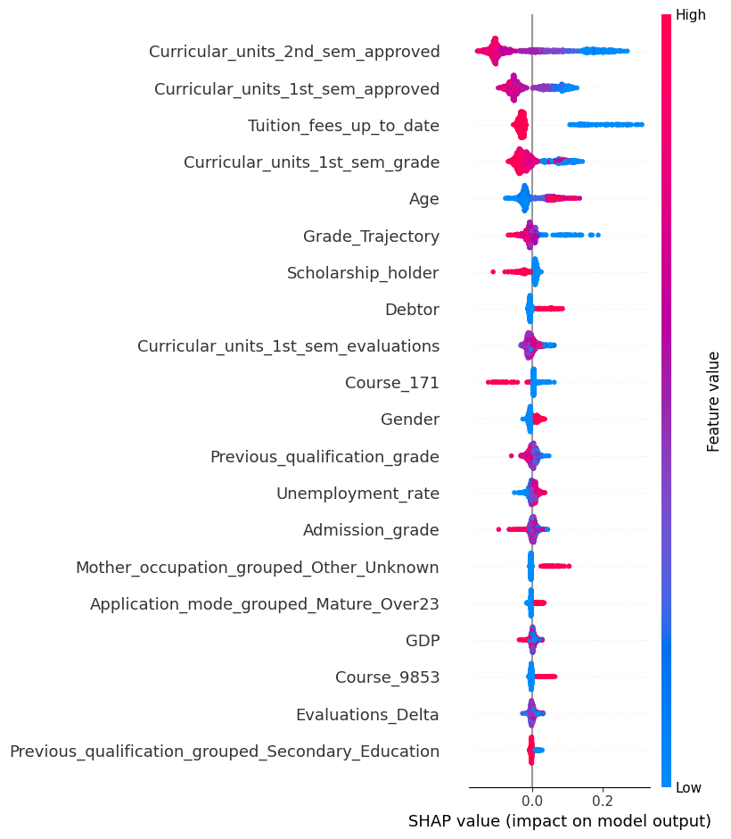
The SHAP summary plot provides global feature importance and improves model transparency for stakeholders.
- Feature Selection
Feature selection was performed using the Variance Threshold method to remove low-variance features that provide limited discriminatory information. This reduces redundant variables and improves computational efficiency before model training.
- Dimensionality Reduction
Dimensionality reduction was performed using Principal Component Analysis (PCA). PCA was used to visualize the data in a lower-dimensional space and investigate class separation, while t-SNE was used to explore nonlinear relationships among student records.
The original feature set was retained for final model training to preserve predictive performance and interpretability.
PCA
pca = PCA(n_components=3)
X_train_pca = pca.fit_transform(X_train_scaled)
PCA Explained Variance per Component: [0.06428999 0.04962296 0.04464724]
Total variance captured by 3 Principal Components: 15.9%
t-SNE
from sklearn.manifold import TSNE

tsne = TSNE(
n_components=2,
perplexity=30,
random_state=42
)
X_tsne = tsne.fit_transform(X_train_scaled)
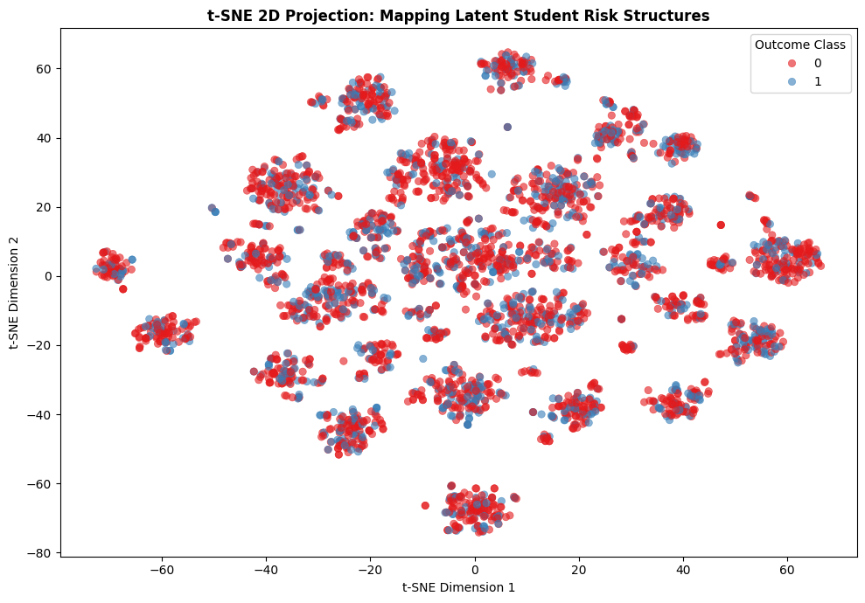
The plot shows that students with varying profiles that separate them into different clusters are not the driving factor behind whether a student ends up in the risk group or not.
Step 4: Model Implementation
- Model Implementation
Multiple supervised machine learning algorithms were implemented to identify the most suitable model for predicting student dropout. The evaluated models include:
- Logistic Regression
- Decision Tree
- Random Forest
- K-Nearest Neighbors (KNN)
- Support Vector Machine (SVM)
- XGBoost
To improve model performance, hyperparameter tuning was performed using RandomizedSearchCV, and 5-fold cross-validation was applied to ensure robust model evaluation.
Example code:
xgb_param_grid = {
'n_estimators': [100, 150, 200, 300],
'max_depth': [3, 4, 5],
'learning_rate': [0.01, 0.03, 0.05, 0.1],
'subsample': [0.7, 0.8, 0.9],
'colsample_bytree': [0.6, 0.8, 0.9]
}
xgb_search = RandomizedSearchCV(
estimator=XGBClassifier(random_state=42, eval_metric='logloss'),
param_distributions=xgb_param_grid,
n_iter=10, cv=5, scoring='f1', n_jobs=-1, random_state=42
)

The best parameters generated from this are used to tune the XGBoost model.
xgb = XGBClassifier(
n_estimators=150,
learning_rate=0.05,
max_depth=3,
subsample=0.7,
colsample_bytree=0.6,
objective='binary:logistic',
scale_pos_weight=imbalance_ratio,
eval_metric='logloss',
random_state=42,
n_jobs=-1
)
xgb.fit(X_train_scaled, y_train_int)

- Model Evaluation & Comparison
Each model was evaluated using multiple classification metrics to provide a comprehensive performance comparison. The evaluation metrics include:
- Accuracy
- Precision
- Recall
- F1-Score
Additional evaluation techniques included:
- Confusion Matrix
- Cross-validation
These metrics enable objective comparison and ensure that model selection is based on overall predictive performance rather than a single metric.
# Predict and evaluate
y_pred_xgb = xgb.predict(X_test_scaled)

print("\nXGBOOST PERFORMANCE REPORT:\n")
print(classification_report(y_test_int, y_pred_xgb, target_names=['Dropout', 'Enrolled', 'Graduate']))

# Plot the confusion matrix
cm_xgb = confusion_matrix(y_test_int, y_pred_xgb)
fig, ax = plt.subplots(figsize=(7, 5))
disp_xgb = ConfusionMatrixDisplay(confusion_matrix=cm_xgb, display_labels=['Dropout', 'Enrolled', 'Graduate'])
disp_xgb.plot(cmap='Purples', ax=ax, values_format='d')
plt.title('XGBoost Matrix', fontsize=11, fontweight='bold', pad=12)
plt.show()

- Reproducibility
To ensure reproducibility, all experiments were implemented using a fixed random seed and documented in Jupyter Notebook.
The final trained model and preprocessing objects were saved using joblib, allowing the model to be reloaded for future prediction or deployment without retraining.
import joblib

joblib.dump(best_model, "models/student_dropout_model.pkl")
joblib.dump(scaler, "models/scaler.pkl")

- Model Selection
The performance of all candidate models was compared using the evaluation metrics described above.
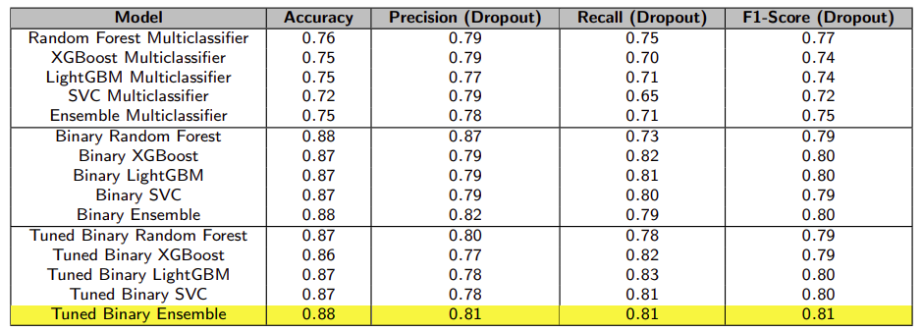
The final model was selected based on its ability to achieve the best overall balance between Recall, F1-Score, while maintaining good generalization performance through cross-validation.
This selection is appropriate because the primary objective of the project is to identify students at risk of dropping out. Therefore, correctly identifying high-risk students (high Recall) is more important than maximizing overall Accuracy alone.
The selected model was then used for explainability analysis using SHAP and prepared for deployment.
Step 5: Critical Thinking → Ethical AI & Bias Auditing
- Model Explainability
To improve model transparency, SHAP (SHapley Additive Explanations) was used to explain the predictions of the selected machine learning model.
SHAP identifies the contribution of each feature to the prediction and provides both global and local explanations. This enables stakeholders to understand which factors most influence a student's predicted dropout risk.
# Initialize Tree Explainer
explainer_bin = shap.TreeExplainer(rf_binary)
# Extract SHAP values from the test set
shap_values_bin = explainer_bin.shap_values(X_test_bin_scaled)
# Generate the plot
shap.summary_plot(
risk_shap_values,
X_test_bin_scaled.values,
feature_names=X_test_bin_scaled.columns
)
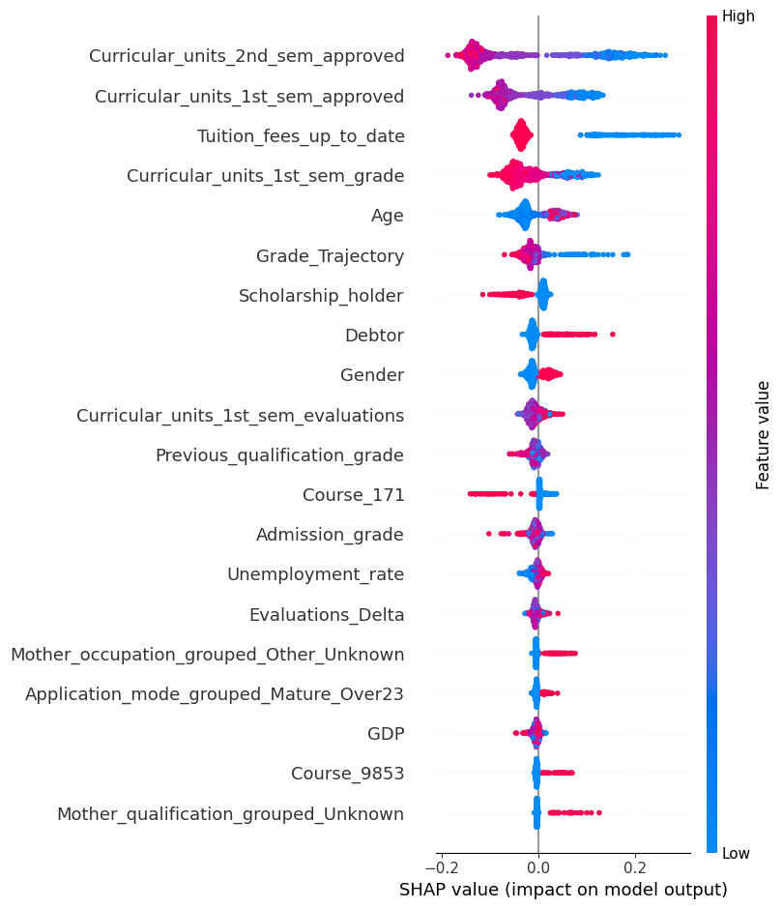
The SHAP summary plot indicates that academic performance, tuition payment status, and financial-related variables are among the most influential predictors of student dropout.
target_feature = 'Curricular_units_2nd_sem_approved'
fig, ax = plt.subplots(figsize=(9, 6))

# Build the combined PDP and ICE display
display = PartialDependenceDisplay.from_estimator(
estimator=tuned_ensemble,
X=X_train_bin_scaled,
features=[target_feature],
kind='both',
pd_line_kw={"color": "red", "linewidth": 4},
ice_lines_kw={"color": "teal", "alpha": 0.05, "linewidth": 0.5},
ax=ax,
n_jobs=-1
)
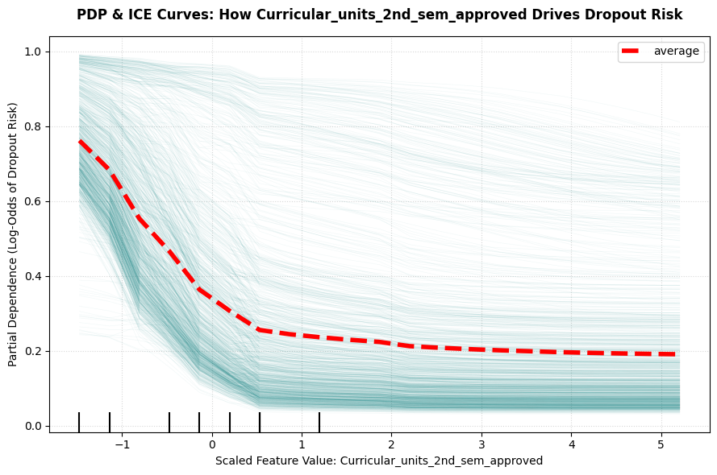
The PDP and ICE Curves shows that the second semester’s approved units have massive impact to the model’s predictions, as the lower the units approved the more the drop out risk.
- Model Limitations
Several limitations were considered during model development.
- Class Imbalance
The original dataset contains three outcome classes with different class distributions. To align with the project objective, the problem was transformed into a binary classification task (Dropout vs. Non-Dropout). The class imbalance is still there with Dropout at 32.12% and Non-Dropout at 67.88% so the choice of success metric is F1-score to compensate it.
- Data Leakage
Feature engineering and preprocessing were performed before model training, and the dataset was split into training and testing sets to reduce the risk of information leakage. To prevent leakage, scaling is done after splitting the dataset.
- Overfitting
To improve model generalization, the models were evaluated using cross-validation and hyperparameter tuning. Performance was assessed on unseen test data rather than relying solely on training accuracy.
# Compute learning curve data
train_sizes, train_scores, test_scores = learning_curve(
estimator=tuned_ensemble,
X=X_train_bin_scaled,
y=y_train_bin_int,
train_sizes=np.linspace(0.1, 1.0, 5),
cv=3,
scoring='f1',
n_jobs=-1
)
# Calculate means
train_mean = np.mean(train_scores, axis=1)
test_mean = np.mean(test_scores, axis=1)
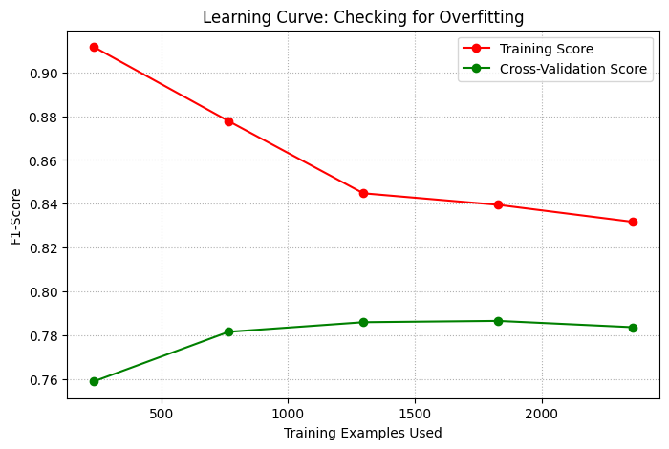
- Bias & Fairness Analysis
The dataset contains several demographic and socioeconomic attributes, including:
- Gender
- Age at enrollment
- Debtor status
These attributes may introduce unintended bias if the model performs differently across student groups.
# Map the binary 0 and 1 to clean text strings
sensitive_feature_gender = X_test['Gender'].map({0: 'Female', 1: 'Male'})
# Generate predictions from tuned ensemble
y_pred = tuned_ensemble.predict(X_test_bin_scaled)
# Create a MetricFrame to slice performance across groups
metrics = {
'Accuracy': accuracy_score,
'F1-Score': f1_score,
'Selection Rate (Rate of flagging Risk)': selection_rate
}
metric_frame_gender = MetricFrame(
metrics=metrics,
y_true=y_test_bin_int,
y_pred=y_pred,
sensitive_features=sensitive_feature_gender # <-- Pass the mapped text version here
)
PER-GROUP PERFORMANCE AUDIT:
Accuracy F1-Score Selection Rate (Rate of flagging Risk)
Gender
Female 0.873684 0.797753 0.310526
Male 0.882540 0.826291 0.342857
# Define a mapping function for age group
def assign_age_group(age):
if age <= 21:
return 'Traditional (<=21)'
elif age <= 30:
return 'Young Adult (22-30)'
else:
return 'Mature-Age (>30)'
# Apply the function to make a new column for train and test sets
X_train['Age_Group'] = X_train['Age'].apply(assign_age_group)
X_test['Age_Group'] = X_test['Age'].apply(assign_age_group)
Train Set Age Group Distribution:
Age_Group
Traditional (<=21) 2316
Young Adult (22-30) 688
Mature-Age (>30) 535
# Demographic Parity Difference
# Ideal: 0.0 (Every group is flagged as "Risk" at the exact same rate)
dp_diff = demographic_parity_difference(
y_test_bin_int, y_pred, sensitive_features=sensitive_feature_gender
)
# Equalized Odds Difference
# Ideal: 0.0 (The True Positive Rate and False Positive Rate are equal across all groups)
eo_diff = equalized_odds_difference(
y_test_bin_int, y_pred, sensitive_features=sensitive_feature_gender
)
# Disparate Impact Ratio
# Ideal: 80% to 125% (The ratio of selection rates between the lowest group and highest group)
group_selection_rates = metric_frame_gender.by_group['Selection Rate (Rate of flagging Risk)']
disparate_impact = group_selection_rates.min() / group_selection_rates.max()
GLOBAL FAIRNESS AUDIT METRICS:
🔹 Demographic Parity Difference: 0.0323
🔹 Equalized Odds Difference: 0.0448
🔹 Disparate Impact Ratio: 0.9057
sensitive_feature_age = X_test['Age_Group']
metric_frame_age = MetricFrame(
metrics=metrics,
y_true=y_test_bin_int,
y_pred=y_pred,
sensitive_features=sensitive_feature_age
)
PER-GROUP PERFORMANCE AUDIT:
Accuracy F1-Score \
Age_Group
Mature-Age (>30) 0.874016 0.789474
Traditional (<=21) 0.888689 0.823864
Young Adult (22-30) 0.845771 0.780142

Selection Rate (Rate of flagging Risk)
Age_Group
Mature-Age (>30) 0.314961
Traditional (<=21) 0.314183
Young Adult (22-30) 0.348259
- Bias Mitigation Strategies
To promote responsible AI, the following mitigation strategies are recommended:
- Evaluate model performance separately for different demographic groups (e.g., gender and age).
- Apply fairness metrics such as Demographic Parity and Equalized Odds before deployment.
- Retrain the model using balanced datasets if significant bias is detected.
- Regularly monitor model performance after deployment and update the model with new student data.
- Use SHAP explanations to support transparent and interpretable decision-making by academic advisors.

